Flashcard Application - Maria and her Minions

Group Members
Name | Admission Number
Maria Muwale | 192414
Nathan Achar | 189206
Githinji Mugambi | 189596
Allan Waithaka | 191604
Faith Muthoni | 178509

What exactly does our project do?
Our project implements a flashcard study tool that mimics how learners use revision cards — flipping through them, going back, tagging useful ones, and dynamically updating the collection. We used four key data structures — linked list, queue, stack, and hash map — to model this behavior. MongoDB was used to store flashcards in the cloud.

Which structures did we use and why?
Data Structure | Usage | Why We Used It
Linked List | Flashcard storage in memory | Dynamic and flexible add/edit/delete
Queue | Review flow (FIFO order) | Mimics normal flashcard flow
Stack | Flip-back or 'undo' feature | Follows LIFO for card history
Hash Map | Bookmarks & tag-based lookup | Allows instant access to key cards

Which technologies were used to achieve our project?
- Python 3
- MongoDB Atlas (NoSQL cloud database)
- pymongo (MongoDB Python driver)
- Git & GitHub (collaboration & version control)
- Tkinter GUI

Which group member handled which module?
- Maria Muwale – Queue (Review Flow)
- Created FlashcardQueue class using doubly-linked Nodes
- Implemented enqueue, dequeue, peek, and display methods
- Faith Muthoni – Stack (Flip History)
- Created FlashcardStack class with push, pop, and peek
- Integrated stack updates into the review loop for backtracking
- Tracked previously reviewed flashcards for LIFO-based undo
- Githinji Mugambi – Hash Map (Bookmarks) + Review History
- Designed dictionary-based tag/bookmark system for cards
- Linked cards to topics or 'starred' labels
- Enabled instant retrieval of bookmarked cards
- Enabled the ability to review history
- Nathan Achar – Linked List (Card Storage) + MongoDB
- Built the LinkedList and Node classes for dynamic card management
- Enabled addition, editing, and deletion of flashcards
- Served as the backbone for queue and stack modules
- Set up MongoDB database for storage of data in a cloud platform
- Allan Waithaka – Interface + Integration
- Built the CLI menu to allow user interaction
- Integrated all modules: database, queue, stack, bookmarks
- Tested end-to-end functionality and handled edge cases

Time and Space Complexity Summary

Data Structure | Operation | Time Complexity | Space Complexity
Queue | Enqueue | O(1) | O(1)
 | Dequeue | O(1) | O(1)
 | Peek | O(1) | O(1)
 | Show All | O(n) | O(1)
Stack | Push | O(1) | O(1)
 | Pop | O(1) | O(1)
 | Peek | O(1) | O(1)
Linked List | Add Card | O(1) | O(1)
 | Edit/Delete/Search | O(n) | O(1)
 | Display All | O(n) | O(1)
Hash Map | Add Bookmark | O(1) | O(1)
 | Remove Bookmark | O(1) | O(1)
 | Lookup Bookmark | O(1) | O(1)
 | Get All Bookmarks | O(k) | O(k)

Steps for running the project
- Ensure you have python 3 installed, a stable internet connection and MongoDB in the main file. If you don't have MongoDB, run pip install pymongo.
- Run the program in the gui1.py file, which is in the ui folder.

References
Python Tkinter - GeeksforGeeks https://share.google/auR7N0TiMX3kKpDKx
https://cloud.mongodb.com/v2/686543a330bb7741eb21af3c#/explorer/686622ee77ada12f30b63504/flashcard_app/flashcards/find

Screenshots

- Adding a flashcard
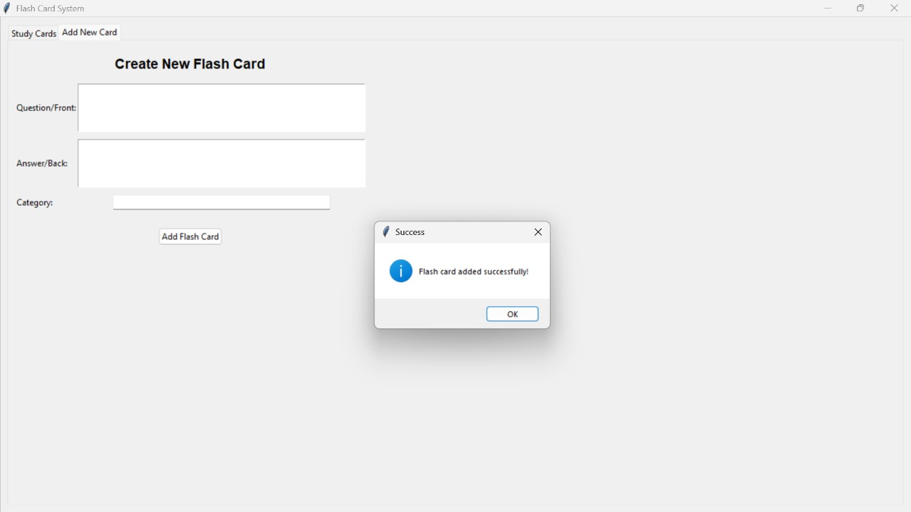
- Viewing the flashcard
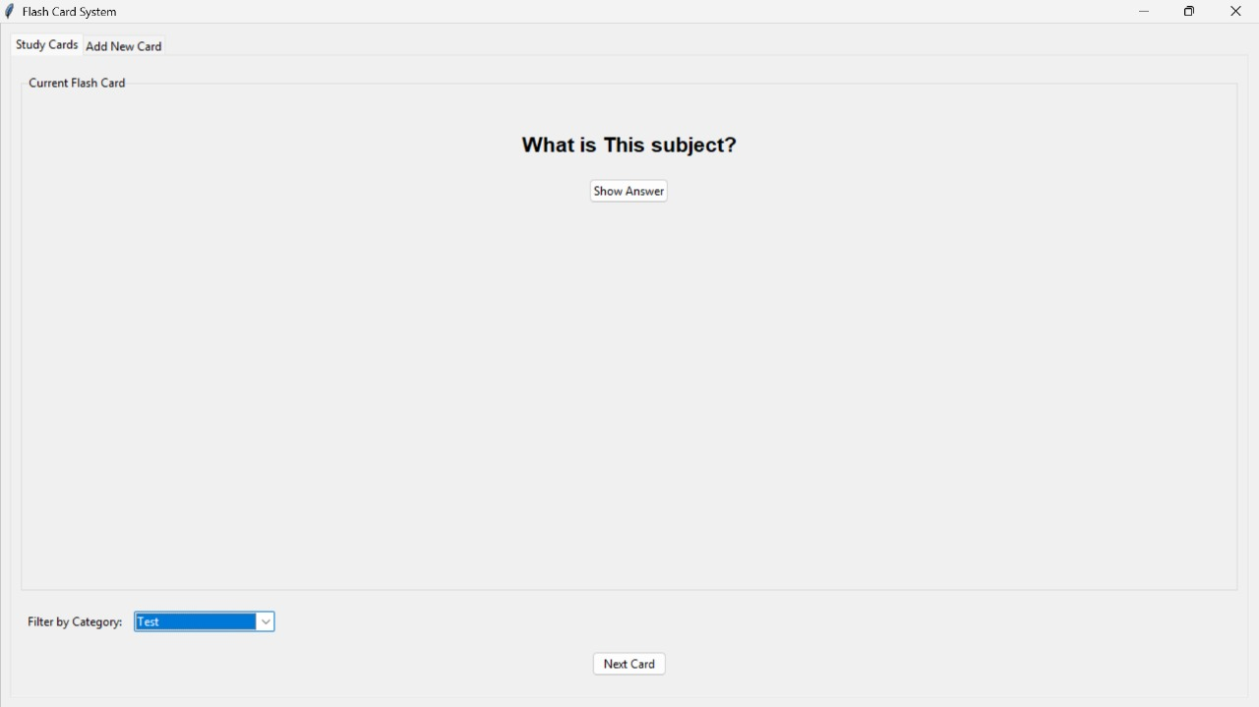
- Viewing the categories/bookmarks
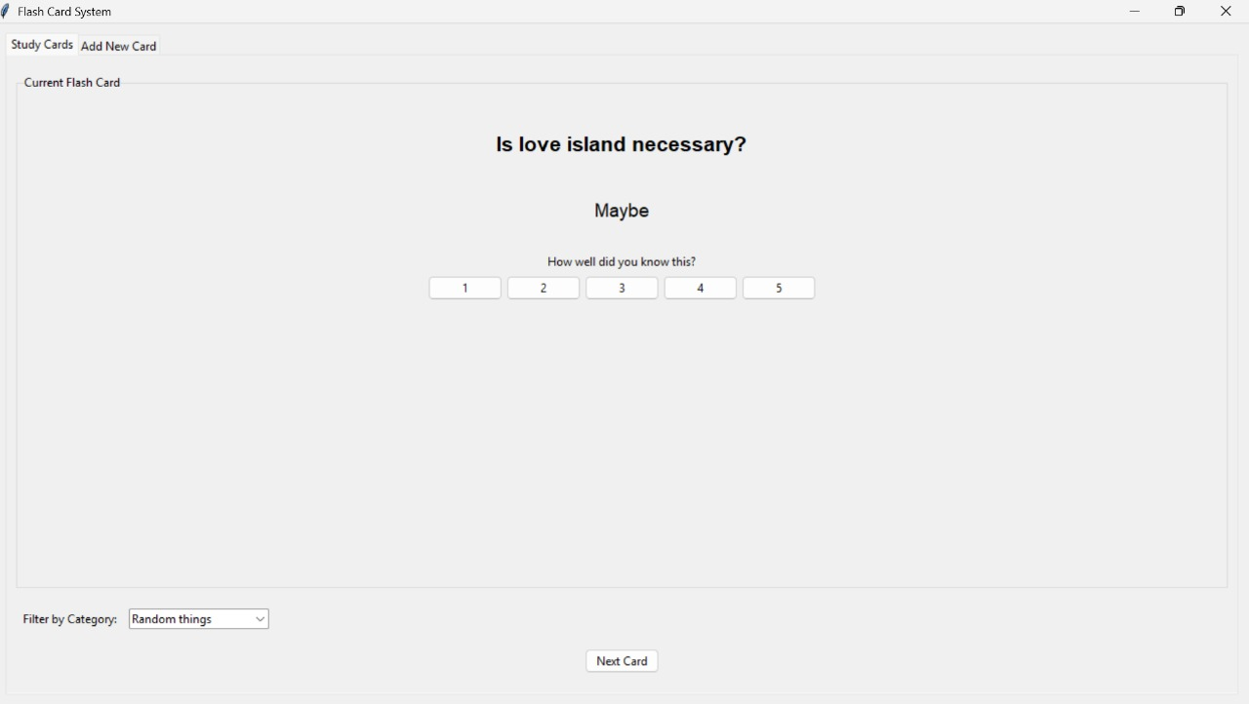
- Review history

